Matahari di Timur
Comprehension Questions based on excerpts from comic.

Papua
Please mark the following on the map.
- Java
- Bali
- Papua
- The major city in Papua
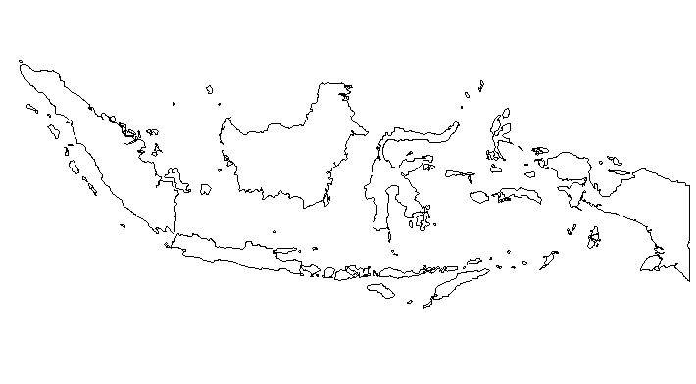

Please answer the following questions, and post your answers online as directed by your teacher.

Before 2002, West Papua had a different name – what was this name?

Suku dan Bahasa

From the reading, please highlight the following words and work out what they mean:
- Grup etnis
- Bahasa
- Kegiatan formal
- Sekolah

- What is an ethnic group?
- What are the most well know ethnic groups of Papua?
- How many languages are there in Papua?
- What is the main language used for formal purposes in Papua?
- What are the similarities between Papua and Aboriginal people in Australia?

Rumah Tradisional

From the reading, please highlight the following words and work out what they mean:
- Jendela
- Rumah

- What is a traditional Papuan house called?
- Describe a “honai”.
- What would you prefer: to visit or live in a house like this?

Senjata Tradisional

- From the reading, please highlight the following words and work out what they mean:
- Tradisional –
- Bambu -
- Senjata -

- How did you work this out?

- What are the traditional weapons?

Hewan Unik

From the reading can you work out what the following words mean:
- Tradisional –
- Bambu -
- Senjata -

- What does the word “fauna” mean?
- What are the animals Papua is well known for?
- Can you describe them?
- What do Papuans do with Cendrawasih feathers?

Extension – Impressions of Indonesia.
Write a short reflection paragraph answering the following questions:

What is your general impression of Indonesia? Is there a “typical Indonesian” person in your mind when you think of Indonesia?
Reflect upon this, and consider how your impression is formed…
(Is it influenced by the Ketut advertisements on television? Is it influenced from your trips to Bali or you have friends that are Indonesia?)
Does the information we learned about Papuan culture differ from what you originally believed about Indonesia? Expand and explain.

