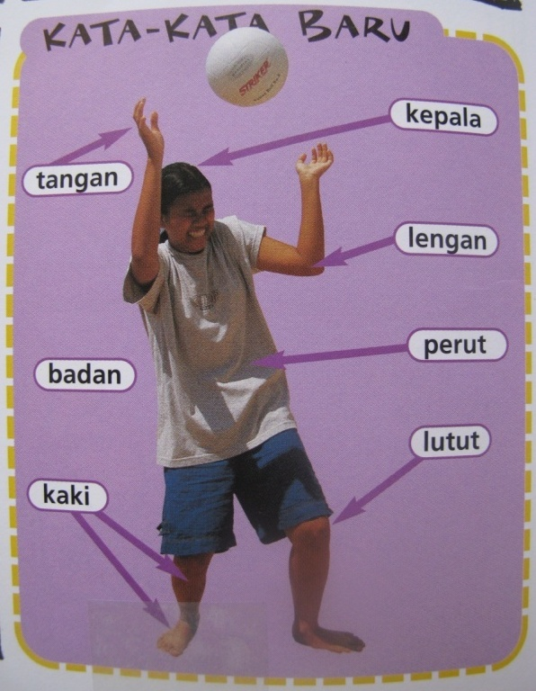

Repair phrases

What does … mean? - **Apa artinya …?**

Excuse me, I’m confused! - **Permisi, saya bingung!**

Can you please repeat? - **Bisa sekali lagi?**

Yes, I understand. - **Ya, saya mengerti.**

I don’t understand. - **Saya tidak mengerti.**

Um….. – **Anu…**

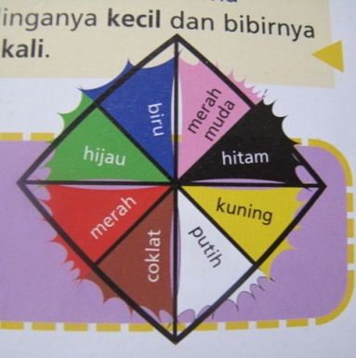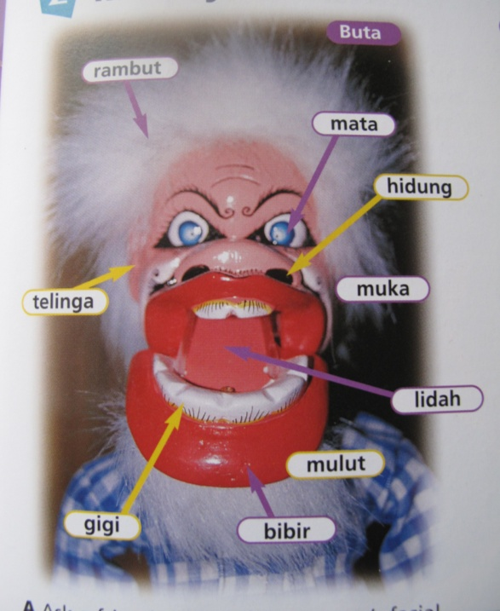

Bagaimana dia?

|  |  |  |
| --- | --- | --- |
| Big – **besar**  Small – **kecil**  Skinny – **kurus**  Fat – **gemuk**  Short - **pendek**  Long - **panjang**  Curly - **keriting**  Straight – **lurus**  Blonde - **pirang** | Strong – **kuat**  Ugly **– jelek**  Stupid – **bodoh**  Kind – **baik hati**  Friendly - **ramah**  Crazy – **gila**  Old – **tua** | Pretty – **cantik**  Handsome - **ganteng**  Young – **muda** |

|  |  |  |
| --- | --- | --- |
| - Sentence Structures - | | |
| Their/His/Her hair is coloured green and curly. | **=** | **Rambutnya berwarna hijau dan keriting.** |
| Their nose is very big. | **=** | **Hidungnya besar sekali.** |
| Lady Gaga is crazier than Costa. | **=** | **Lady Gaga lebih gila daripada Costa.** |
| Homer Simpson is not ruder than Mr Bean. | **=** | **Homer Simpson tidak lebih kasar daripada Mr Bean.** |
| Jim Carey is the funniest. | **=** | **Jim Carey paling lucu.** |

*The underlined words can be swapped with other words!